**World Map**

The World Map guides players throughout the game and allows them to decide which paths to take to the end of the game.

**Sub-features**

Area Select, confirmation windows and visual pathing.

**Essence statement**

The player must make choices about where to go in the World Map and can never see the whole game in one playthrough which promotes replayability.

**Player Story**

The player has finished the first area in the game and must decide if they want to battle GI Joes or stuffed animals next, knowing that this choice will alter their path the rest of the game.

**Anti-Vision**

This World Map does not allow for back tracks or side movement across tiers.

This World Map does not display all choices, only those directly next to the player’s completed areas.

**Reference Material**

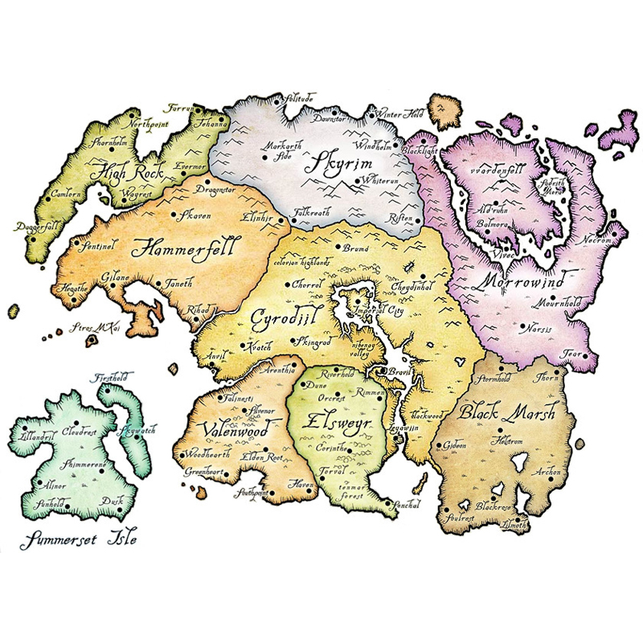

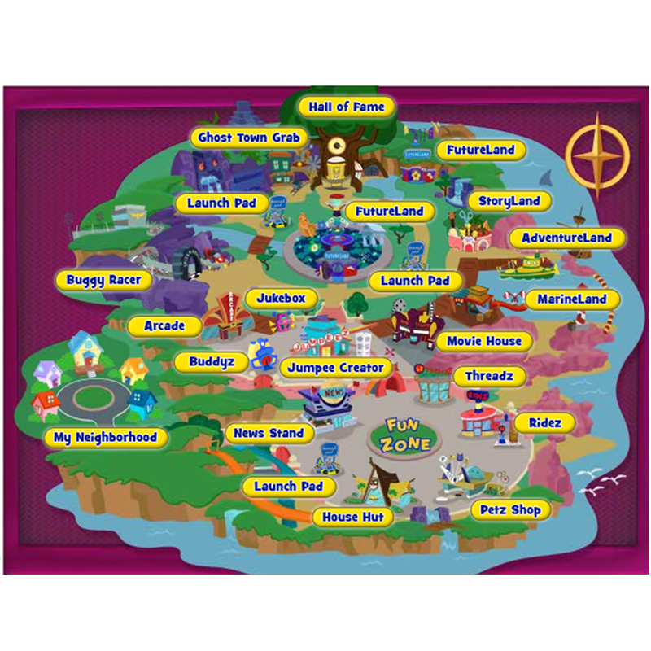

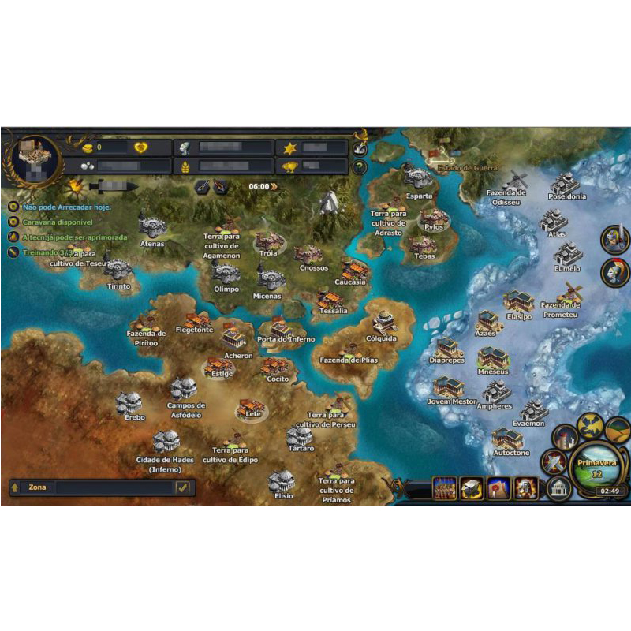

**Controls**

Controls within the World Map will all be used through the mouse. Targeting an area to go and double clicking will confirm the players selection after a confirmation window. “Travel to Candyland?” “OK”/”NO”.

**Objectives and Requirements- Minimum**

This map must show players surrounding areas and allow them to choose where to go next. Double clicking an area will take the player there. No backtracking to past levels is allowed. Map will be laid out visually like examples but with minimal detail in the artwork. Solid bright colours to represent different areas and reflect the idea of a childs imagination. Previous completed levels will be checked off and paths not taken will be scribbled out with a crayon. Areas that were just unlocked will be lit up and able to select and will display the name of the area.

**Design Behaviour**

Players will encounter the World Map at the end of every level they have won. The Map will have the new areas unlocked visible to the player with lit paths from the just completed level to the new options and when they hover the mouse over the new area it will light up with faint particle effects. Completed areas have a trophy or star rating and areas that were not chosen are greyed out. When the player double clicks an area a confirmation message will appear. If the player continues with selection they are transferred to the first level in that area. In the World Map players hear background ambient music and they hear a selection sound when clicking an area or hitting “OK”.

**Objectives and Requirements- Shipping**

This map must show players surrounding areas and allow them to choose where to go next. Double clicking an area will take the player there. No backtracking to past levels is allowed. Visually, the World Map will resemble a real map with different color schemes for areas to match the theme (EG:GI Joe area looks camo) and a small icon of the type of toys the player will encounter there along with the type written out and a difficulty rating on the area. Completed areas may display a star rating reflecting the players performance.

**Objectives and Requirements- Stretch**

This map must show players surrounding areas and allow them to choose where to go next. Double clicking an area will take the player there. No backtracking to past levels is allowed. Visually, the World Map will resemble a real map with differennt color schemes for areas to match the theme (EG:GI Joe area looks camo) and a small icon of the type of toys the player will encounter there along with the type written out and a difficulty rating on the area. When an area is clicked once the view zooms in to enlarge that area and you can see sprites of the units you will encounter walking around the area and the player can choose to hit the “Play Area” button or “Back” button.